**Certificate of Analysis**

|  |  |  |  |
| --- | --- | --- | --- |
| **Item** | **CAL-HYPO 65%** | **CAL-HYPO 70%** | **TEST**  **RESULT** |
| *Available Chlorine % | 65.0min | 70.0min | 71.9% |
| *Water % | 5.5-10 | 5.5-10 | 7 |
| *Granular Size(14~50mesh)% | 90min | 90min | 95 |
| Bulk Density g/ml | 1.0-1.1 | 1.0-1.1 | 1.0-1.1 |
| Insolubility matter | 6.0max | 5.0max | 4.5 |
| CaCO3 % | 3max | 2max | 1.5 |
| Ca(OH)2 % | 6max | 4max | 3.3 |
| CaCl2 % | 3max | 2 max | 1.6 |
| NaCl % | 12-20 | 12-20 | 15 |
| Ca(ClO3)2% | 2max | 2max | 1 |
| MgCl2 % | 0.01max | 0.01max | 0.005 |
| Fe2O3 % | 0.001 max | 0.001 max | 0.0006 |
| Al2O3 % | 0.0001 max | 0.0001 max | 0.00007 |
| pH (1% solution) | 9-12 | 9-12 | 9.4 |

We hereby confirm that the material is in good condition.

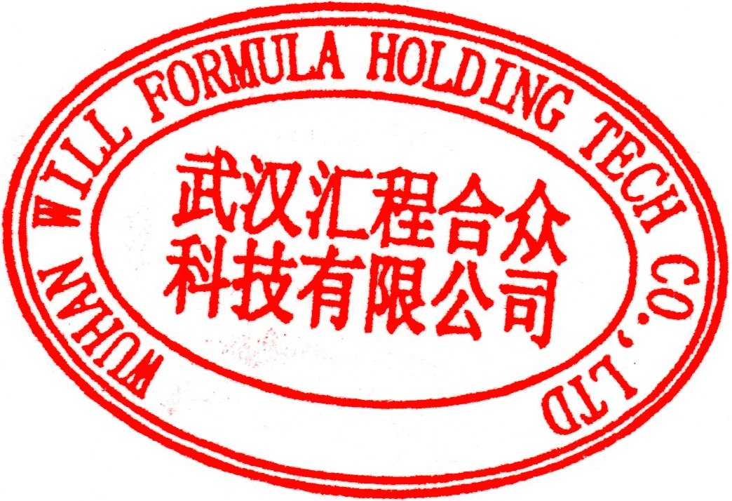

**MANUFACTURING DATE: August 28, 2021**

**ANALYSIS DATE: August 28, 2021**

**EXPIRY DATE：August 27, 2023**

**BATCH NO.: 20210828**

